

**Movie Theater**

Software Requirements Specification

Version 1.1

**Hanoi, Jan 2020**

**Approval Page**

|  |  |
| --- | --- |
| **Prepared by :** | Signature: |
| Business Analyst |  |
|  | Date: |
|  | / / |
| **Reviewed by :** | Signature: |
| Business Analyst |  |
|  | Date: |
|  | / / |
| **Supported by:** | Signature: |
|  |  |
|  | Date: |
|  | / / |
| **Approved by :** | Signature: |
|  |  |
|  | Date: |
|  | / / |

**Revision History**

|  |  |  |  |
| --- | --- | --- | --- |
| **Date** | **Version** | **Author** | **Change Description** |
| 15/01/2025 | 1.0 | Ngo Quang Huy | Initial draft |
| 18/01/2025 | 1.1 | Ngo Quang Huy | Update |
| 25/3/2025 | 1.2 | Ngo Quang Huy | Comprehensive update |
|  |  |  |  |
|  |  |  |  |
|  |  |  |  |

**TABLE OF CONTENTS**

1. Introduction 5
   1. Purpose 5
   2. In scope 6
2. Overview 6
   1. Actors 6
   2. Use Case Diagram 6
3. Functional Description 7
   1. Functional Requirements 8
      1. Log in 8
      2. Register account 9
         1. Register account 10
         2. Edit member accounts 12
         3. View member list 15
      3. Account management of the user 17
         1. The user – Booked ticket management 17
         2. The user – View history of score adding/using 18
         3. Movie list – Search of the user 20
      4. Booking ticket of the user 21
         1. Book ticket – Select movie and showtime 21
         2. Booking ticket – Selecting seat 23
         3. Booking ticket – Confirm booking ticket 25
         4. Booking ticket – Ticket information 26
      5. Ticket selling management 27
         1. Ticket selling management – Select movie and showtime 28
         2. Ticket selling management – Selecting seat 30
         3. Ticket selling management – Confirm ticket 32
         4. Ticket selling management – Ticket information 35
      6. Ticket booking management 36
         1. Ticket booking management – Search 36
         2. Ticket booking management – Booking list 37
         3. Ticket booking management – Confirm booking 38
         4. Ticket booking management – Information of converting into ticket 40
      7. Employee management 41
         1. Employee management – View employee list 41
         2. Employee management – Add employee 43
         3. Employee management – Edit employee 45
         4. Employee management – Delete employee 47
      8. Cinema room management 49
         1. Cinema room management – Display list of cinema rooms 49
         2. Cinema room management – Cinema room detail 51
      9. Movie management 52
         1. Movie management – View movie list 52
         2. Movie management – Add movie 54
         3. Movie management – Edit movie information 56
         4. Movie management – Delete movie 58
      10. Promotion management 58
          1. Promotion management – View promotion list 59
          2. Promotion management – Add promotion 60
          3. Promotion management – Edit promotion 61
          4. Promotion management – Delete promotion 63
   2. Detailed Non-Functional Requirements 64
      1. Logical Structure of the Data 64
      2. Security 66
      3. Performance 66

# Introduction

## Purpose

The management system allows to easily perform the functions of the movie theater operation management, especially ticket selling of employees and ticket booking of the users. The biggest goal of the system is to improve the performance of employees, minimize the time to conduct ticket selling with each customer, facilitate booking, increase sales, minimize manpower and make the movie theater more competitive compared with other movie theaters.

The system has user authorization function, so that:

* For users who are customers - not members: can view movie list, view promotions, view ticket prices, view showtimes, register an account, log in.
* For users who are customers - members: the same as customers who are not members, besides, they can book tickets, manage accounts ...
* For users who are employees: view and search members, manage movies, ticket selling, ticket booking, and promotion.
* For users who are shop owners or managers: in addition to the functions of management employee, they can use statistical functions, manage employees, members, cinema rooms...

## In scope

In the movie theatre scope, for learning Mock project, create basic premise for next projects.

# Overview

## Actors

The following table describes actors of the movie theatre management system.

|  |  |  |
| --- | --- | --- |
| **Actor** | | **Description** |
| Admin | | Actor has the highest right in the system, admin can add, edit,  delete all modules in the system. |
| Employee | | Employees who operate directly in the system can manage ticket selling, booking and search for members. |
| Customer | Not member | Operate directly in the user system, with functions: view movie list, view promotions, view ticket price, showtime, and register  accounts |
| Member | Operate functions of customers – not members, besides,  member customers can book tickets, manage accounts and manage ticket booking. |

## Use Case Diagram

The diagram below provides an overview of the function as well as actors of the users

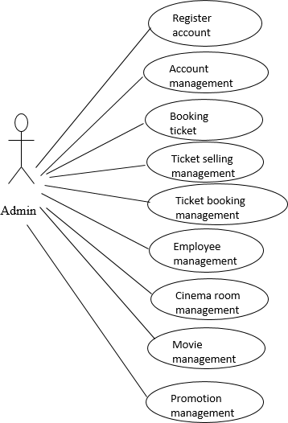

# Functional Description

## Functional Requirements

### Log in

**Users must be authenticated with the provided account and password to access the system.**

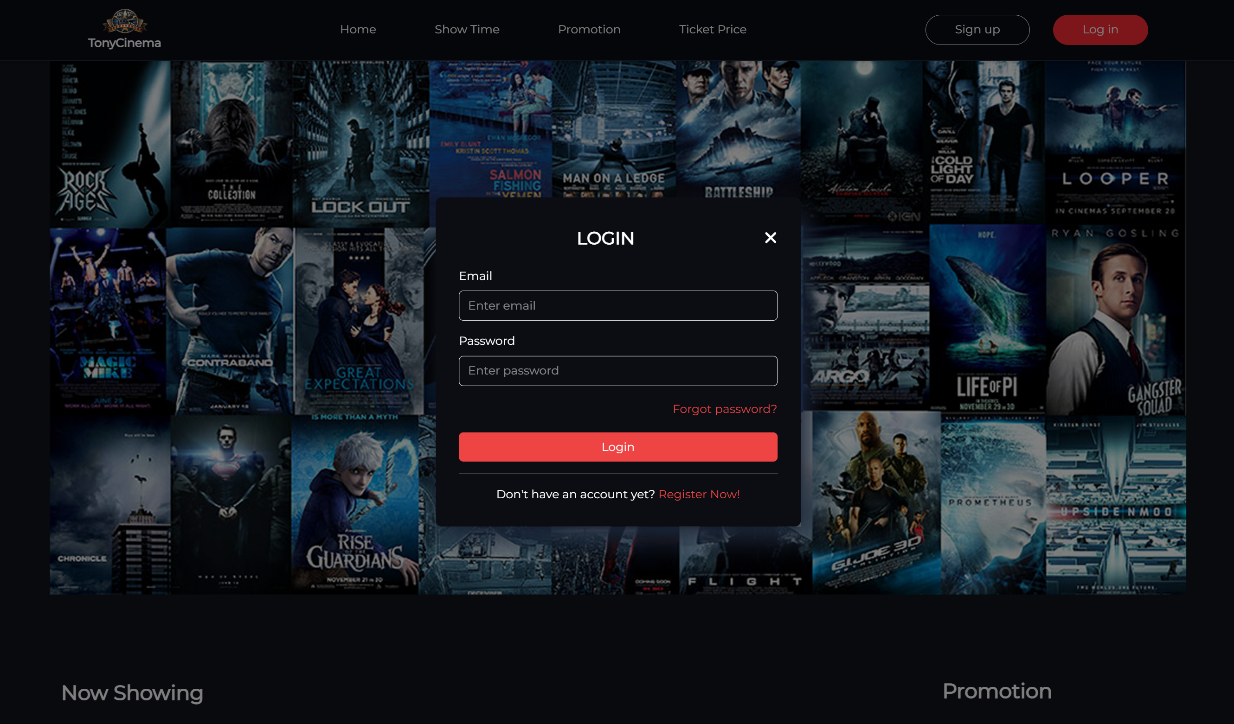

The system provides a login page for users to enter their username and password. The system will verify the entered user information with the user database of the system.

If the account is not found in the system or an account has been found but the entered password does not match the system password, the system will report an error to the user. "User / password is invalid. Please try again!".

If the account is valid but it has been locked, the system will report an error: "Account has been locked!"

If login successfully, the system will check the assigned roles and bring users to the main screen of the application.

### Register account

|  |  |
| --- | --- |
| Use Case Name | Register account |
| Use Case ID |  |
| High Level Requirement Ref |  |
| Actor | User |
| Description | This is a use case which allows the user to register accounts |
| Trigger | NA |
| Pre-condition | The user registers account information |
| Post-processing |  |

#### Register account

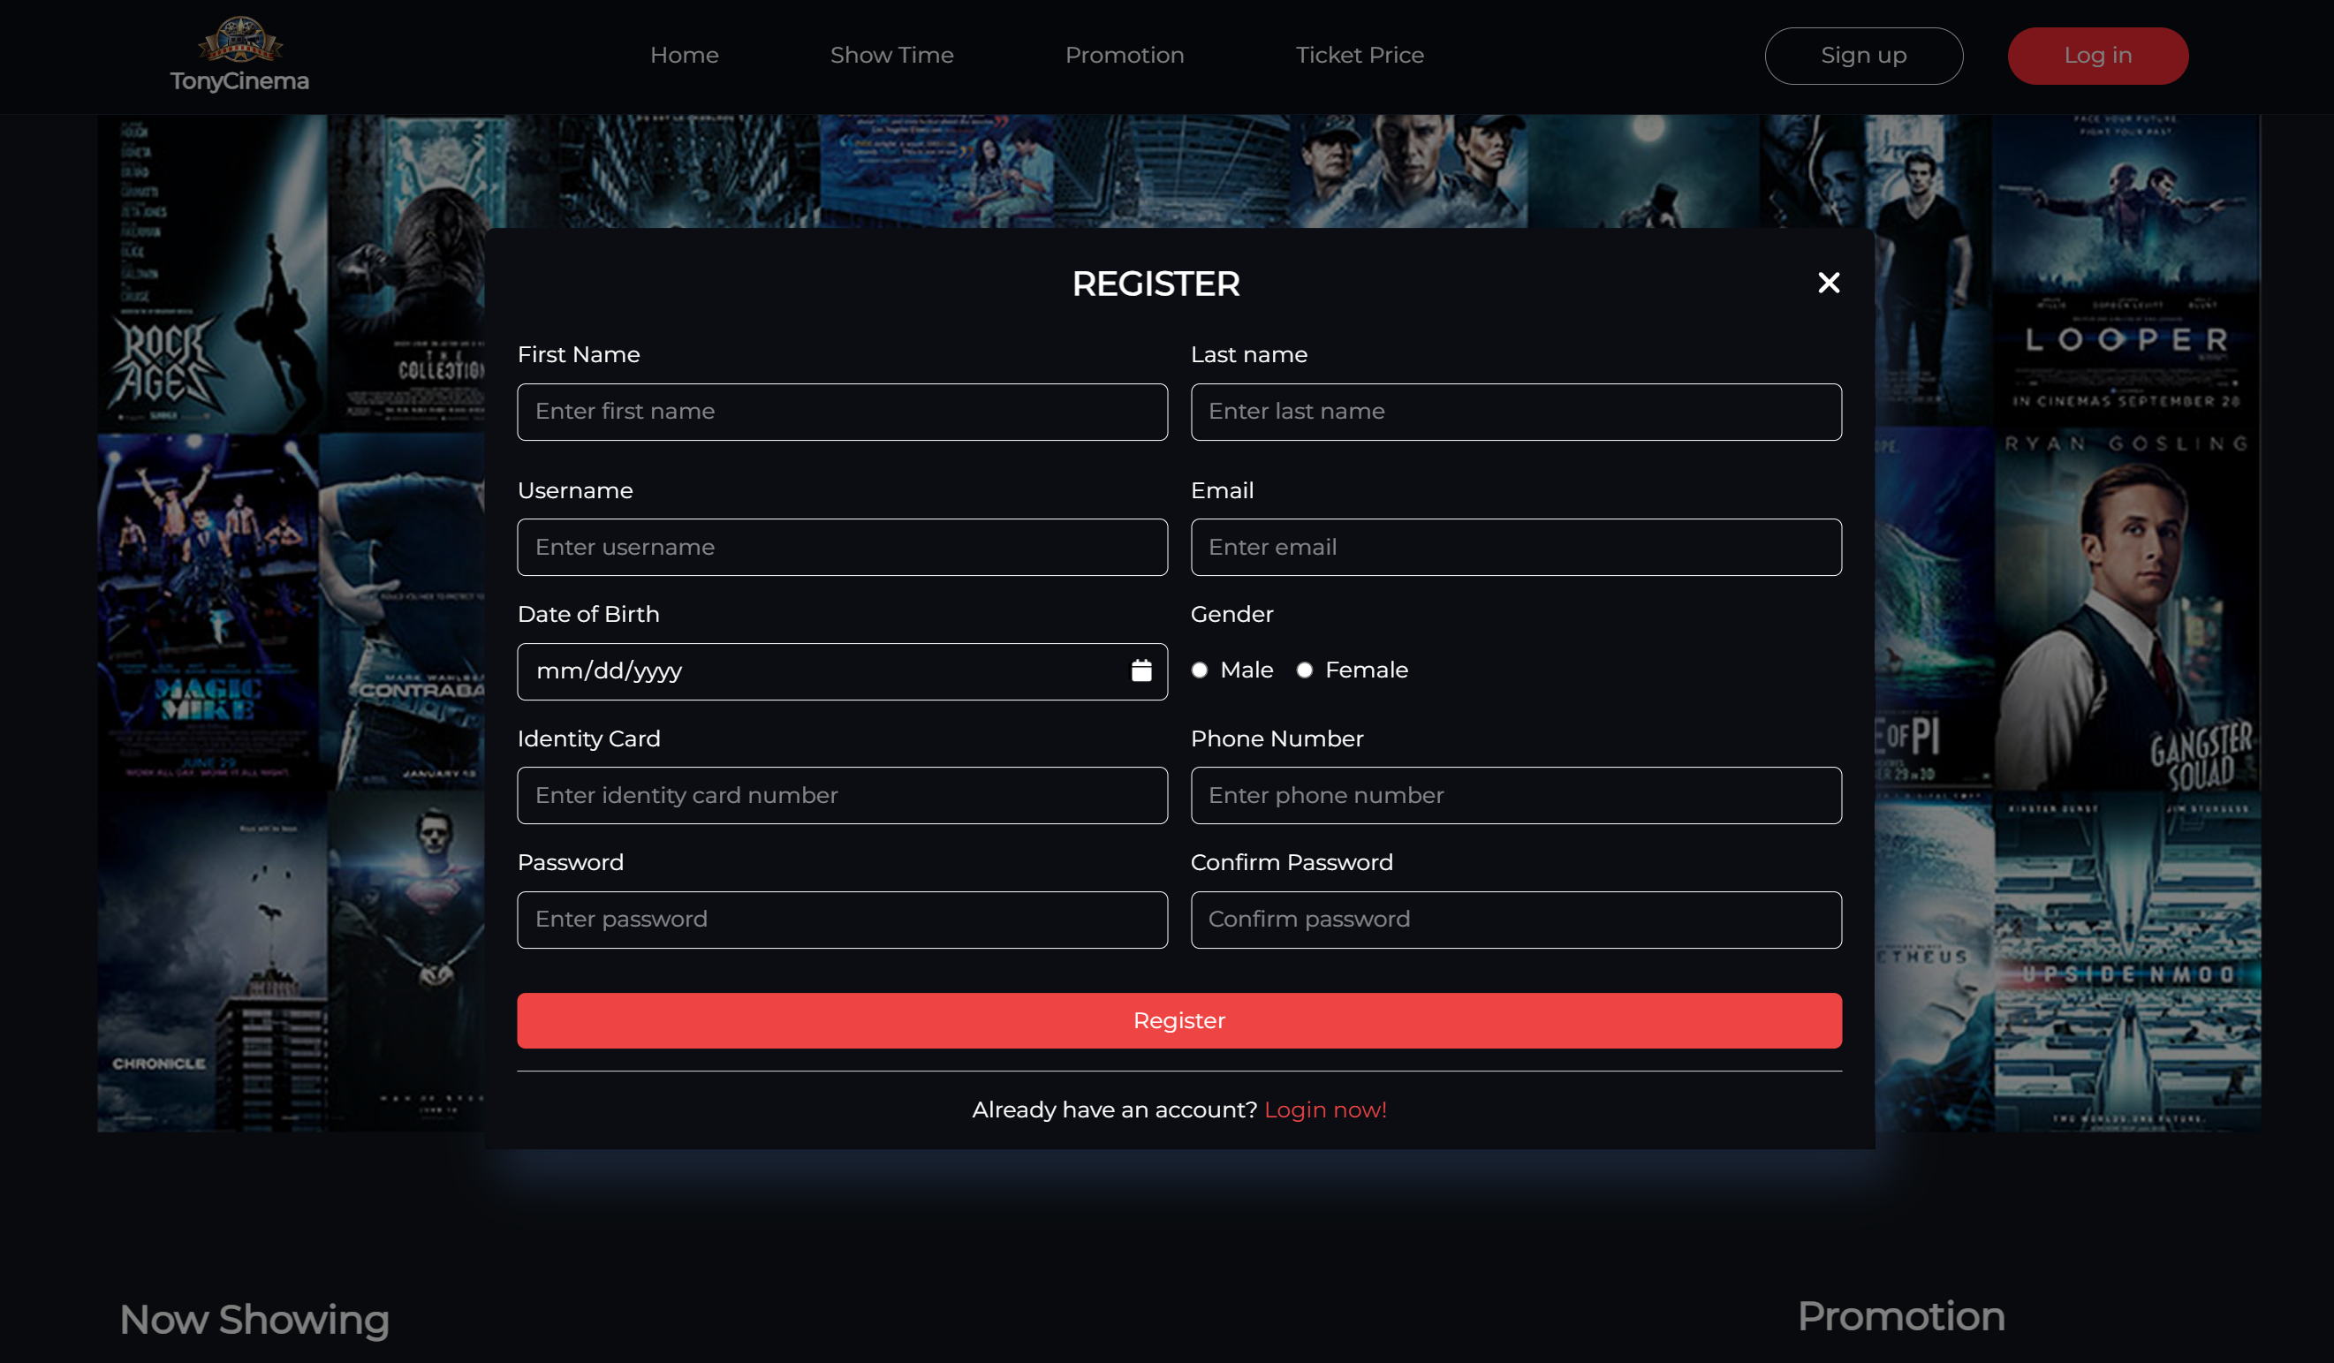

|  |  |  |  |  |
| --- | --- | --- | --- | --- |
| **Screen** | Register account | | | |
| **Description** | Register user information | | | |
| **Screen**  **Access** | The user clicks Register account | | | |
| **Screen Content** | | | | |
| **Item** | **Type** | **Data** | **Description** | |
| First name | Textbox-  String | N/A |  | |
| Last name | TextBox -  String | N/A |  | |
| Confirm  password | Textbox -  String | N/A |  | |
| Username | Textbox -  String | N/A |  | |
| Date of birth | Textbox -  String | N/A |  | |
| Gender | Radiobutton  - String | N/A |  | |
| Email | Textbox –  String | N/A |  | |
| Identity card | Texbox -  number | N/A |  | |
| Phone  number | Textbox -  Number | N/A |  | |
| Password | Textbox -  String | N/A |  | |
| Confirm password | Textbox -  String | N/A |  | |
| Register | Button | N/A |  | |
| Log In | Button | N/A |  | |
| **Screen action** | | | | |
| **Action name** | **Description** | | **Success** | **Failure** |
| Register | Click Register to send data | | Forward to login page to log in the  main page | The required fields are null |
|  |  | |  |  |

### Account management of the user

|  |  |
| --- | --- |
| Use Case  Name | Account management |
| Use Case ID |  |
|  |  |
| Actor | Member |
| Description | This is a use case which allows the users to update information, change password, manage ticket booking, view details of score including added and used scores |
| Trigger | NA |
| Pre-condition | The user with registered account |
| Post-  processing |  |

#### Edit member profile

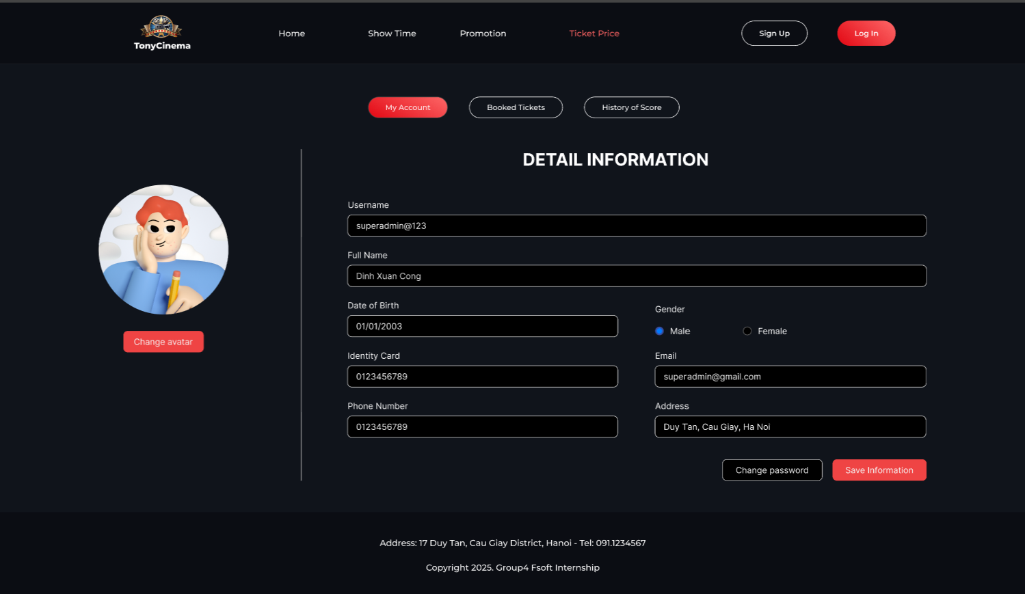

|  |  |  |  |  |
| --- | --- | --- | --- | --- |
| **Screen** | Edit member account | | | |
| **Description** | Display information of member whose account need editting | | | |
| **Screen**  **Access** | The user clicks Edit at Employee list | | | |
| **Screen Content** | | | | |
| **Action name** | **Description** | **Success** | **Failure** | |
| Account | Textbox -  string | N/A |  | |
| Full name | Textbox –  string | N/A |  | |
| Password | Textbox -  string | N/A |  | |
| Date of birth | Textbox -  date | N/A |  | |
| Gender | Radiobutton  - string | N/A |  | |
| Email | Textbox -  string | N/A |  | |
| Identity card | Textbox -  string | N/A |  | |
| Phone  number | Textbox -  number | N/A |  | |
| Address | Textbox -  string | N/A |  | |
| Ticket  management | Link -  string | N/A |  | |
| Employee  management | Link -  string | N/A |  | |
| Member  management | Link -  string | N/A |  | |
| Statistic | Link -  string | N/A |  | |
| Save Information | Button | N/A |  | |
| **Screen action** | | | | |
| **Action name** | **Description** | | **Success** | **Failure** |

#### Change account password

#### The member – Booked ticket management

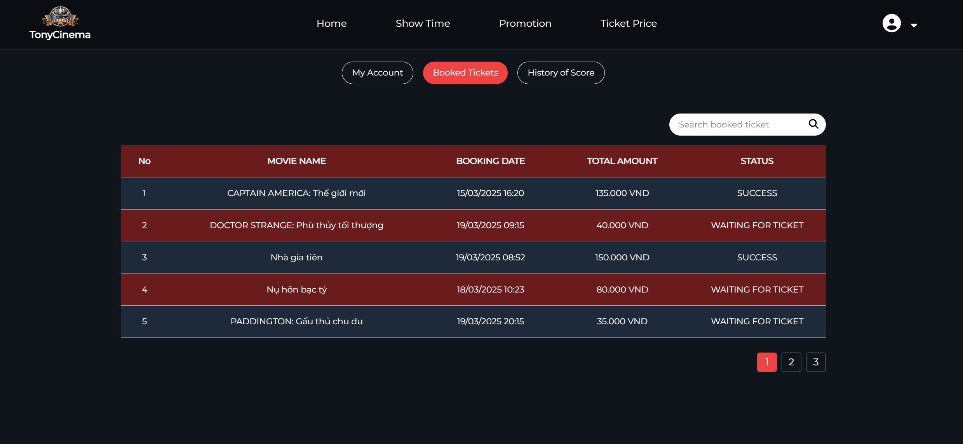

|  |  |  |  |
| --- | --- | --- | --- |
| **Screen** | Booked Tickets | | |
| **Description** | Display all booked tickets of member | | |
| **Screen**  **Access** | Member clicks “View Profile” on the dropdown at the right corner => Booked tickets | | |
| **Screen Content** | | | |
| **Item** | **Type** | **Data** | **Description** |
| No | Guid | N/A |  |
| Movie Name | label-  string | N/A |  |

|  |  |  |  |  |
| --- | --- | --- | --- | --- |
| Booking date | Label -  String | N/A |  | |
| Total Account | Label -  String | N/A |  | |
| Status | Link -  String | N/A |  | |
| **Screen Action** | | | | |
| **Action name** | **Description** | | **Success** | **Failure** |
| Log out | Click the logout button to exit the current member account | | Back to the login screen | No event has been created for the logout  button |

#### The user – View history of score adding/using

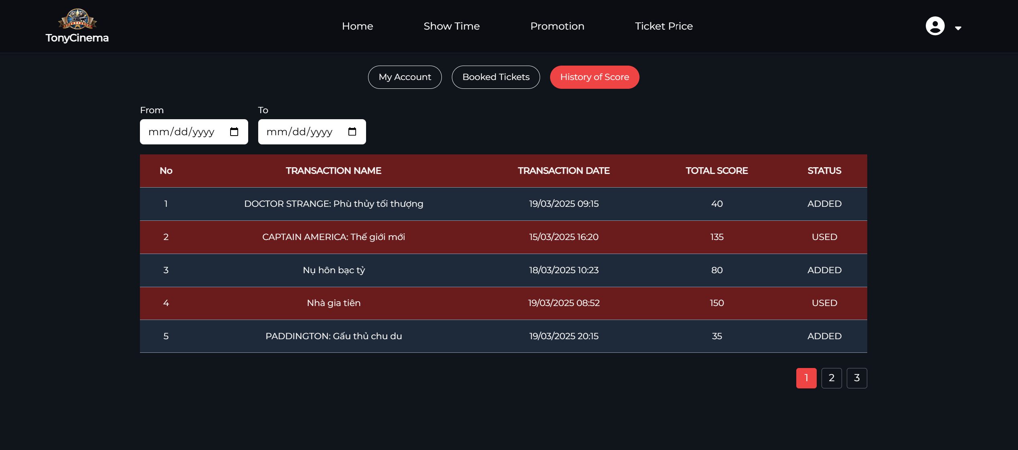

|  |  |  |  |  |
| --- | --- | --- | --- | --- |
| **Screen** | View history of score adding/using | | | |
| **Description** | Display all history of score adding/using of the current member | | | |
| **Screen**  **Access** | The member clicks account management -> History | | | |
| **Screen Content** | | | | |
| **Item** | **Type** | **Data** | **Description** | |
| From date | Date - string | N/A |  | |
| To date | Date - string | N/A |  | |
| History of  score adding | Radiobutton-  String | N/A |  | |
| History of  score using | Radiobutton-  String | N/A |  | |
| Date created | Label -  string | N/A |  | |
| Movie name | Label -  string | N/A |  | |
| Added score | Label -  string | N/A |  | |
| Account  information | Link - String | N/A |  | |
| History | Link - String | N/A |  | |
| Booked  ticket | Link - String | N/A |  | |
| Canceled  ticket | Link - String | N/A |  | |
| Log out | Button | N/A |  | |
| View score | Button | N/A |  | |
|  |  |  |  | |
| **Screen Action** | | | | |
| **Action name** | **Description** | | **Success** | **Failure** |
| Log out | Click the logout button to exit the current member account | | Back to the login screen | No event has been created for the logout  button |
| View score | Click the View score button to see the process of using or adding scores | | Displays a list of added or used  scores | No event created for ViewScore button |

### Booking ticket of the user

|  |  |
| --- | --- |
| Use Case  Name | Booking ticket |
| Use Case ID |  |
|  |  |
| Actor | Member |
| Description | This is the use case which allows users to book ticket |
| Trigger | NA |
| Pre-condition | The user must login account |
| Post-  processing |  |

#### Book ticket – Select movie and showtime

#### 

|  |  |  |  |  |
| --- | --- | --- | --- | --- |
| **Screen** | Book ticket – Select movie and showtime | | | |
| **Description** | Display the current movies and showtime | | | |
| **Screen**  **Access** | The user accesses to book ticket | | | |
| **Screen Content** | | | | |
| **Item** | **Type** | **Data** | **Description** | |
| Select movie | Combobox | N/A | Display current movies for users to  select | |
| Select date | Combobox | N/A | Display the show date of each selected movie in Select movie combobox for  users to select | |
| Select time | Combobox | N/A | Display the showtime of each movie according to the movie and the show  date for the user to select | |
| Book ticket | Button | N/A | Send movie information and  showtime, display the screen of selecting seat | |
| **Screen action** | | | | |
| **Action name** | **Description** | | **Success** | **Failure** |
| Select movie | Display all show dates for the selected movie | | Display all the show date of the selected movie in Select movie  combobox | The list of show dates is empty when no show date is found |
| Select date | Display all showtimes of selected movies | | Display all showtimes of movies according to the show date selected in Select show date  combobox | The list of schedules is empty when no show schedule is found during the day |
| Book ticket | Send ticket booking request, send movie information and showtime | | Display screen of Selecting seat | * If the movie show date has not been selected, display the message "Please select the show date" * If showtime has not been selected, display the message "Please select   showtime" |

#### Booking ticket – Selecting seat

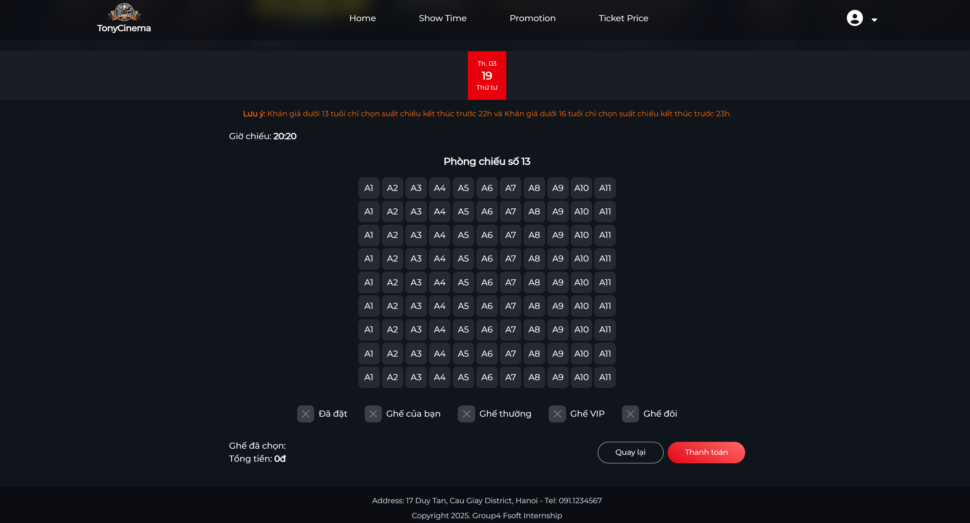

|  |  |  |  |  |
| --- | --- | --- | --- | --- |
| **Screen** | Booking ticket – Selecting seat | | | |
| **Description** | Display seat map of the movie and selected showtime | | | |
| **Screen**  **Access** | The user accesses after selecting movie and showtime | | | |
| **Screen Content** | | | | |
| **Item** | **Type** | **Data** | **Description** | |
| Select seat  quantity | Combobox | N/A | Display list of seat quantity for the  user to select | |
| Seat | CheckBox | N/A | Display seat map for the user to  choose | |
| Continue | Button | N/A | Send information of seat selection and  display the screen of ticket booking information | |
| **Screen Action** | | | | |
| **Action name** | **Description** | | **Success** | **Failure** |
| Select seat  quantity | Display list of seat quantity that  customer needs to select (0, 1, 2, …8) | | Display list of seat  quantity |  |
| Select seat | Display seat map for the customer to choose according to selected seat quantity | | When selecting the seat number as the same as selected seat quantity in combobox of Select seat quantity | If selected seat number is less than the seat quantity at the combobox, display the message "Please selecte x seat more"  - If selected seat number is more than the seat quantity at the combobox, display the message "Please select only x  seat" |

|  |  |  |  |
| --- | --- | --- | --- |
| Continue | Send ticket booking request, send seat selection information and display  booking information screen | Display Confirm booking ticket  screen |  |

#### Booking ticket – Confirm booking ticket

#### 

|  |  |  |  |
| --- | --- | --- | --- |
| **Screen** | Booking ticket – Confirm booking ticket | | |
| **Description** | Display all ticket booking informatiom | | |
| **Screen**  **Access** | The user accesses after selecting seat | | |
| **Screen Content** | | | |
| **Item** | **Type** | **Data** | **Description** |
| Movie name | Label | N/A |  |
| Screen | Label | N/A |  |
| Date | Label | N/A |  |
| Time | Label | N/A |  |
| Seat | Label | N/A |  |
| Price | Label | N/A |  |

|  |  |  |  |  |
| --- | --- | --- | --- | --- |
| Total | Label | N/A |  | |
| Full name | Label | N/A |  | |
| Email | Label | N/A |  | |
| Identity card | Label | N/A |  | |
| Phone  number | Label | N/A |  | |
| Confirm booking  ticket | Button | N/A |  | |
| **Screen Action** | | | | |
| **Action name** | **Description** | | **Success** | **Failure** |
| Confirm booking  ticket | Select to send all ticket booking information | | Display screen of ticket booking  information |  |

#### Booking ticket – Ticket information

|  |  |  |  |  |
| --- | --- | --- | --- | --- |
| **Screen** | Booking ticket – Ticket information | | | |
| **Description** | Display all ticket booking information | | | |
| **Screen**  **Access** | The user accesses after seleting seat | | | |
| **Screen Content** | | | | |
| **Item** | **Type** | **Data** | **Description** | |
| Movie name | Label | N/A |  | |
| Booking ID | Label | N/A |  | |
| Screen | Label | N/A |  | |
| Date | Label | N/A |  | |
| Time | Label | N/A |  | |
| Seat | Label | N/A |  | |
| Price | Label | N/A |  | |
| Total | Label | N/A |  | |
| Full name | Label | N/A |  | |
| Email | Label | N/A |  | |
| Identity card | Label | N/A |  | |
| Phone  number | Label | N/A |  | |
| **Screen Action** | | | | |
| **Action name** | **Description** | | **Success** | **Failure** |

### Ticket selling management

|  |  |
| --- | --- |
| Use Case  Name | Ticket selling management |
| Use Case ID |  |
| High Level  Requirement Ref |  |
| Actor | Admin/Manager/Admin |
| Description | Allows the user to manage selling ticket |
| Trigger | N/A |
| Pre-condition | The user must log in the system |
| Post-  processing |  |

#### Ticket selling management – Select movie and showtime

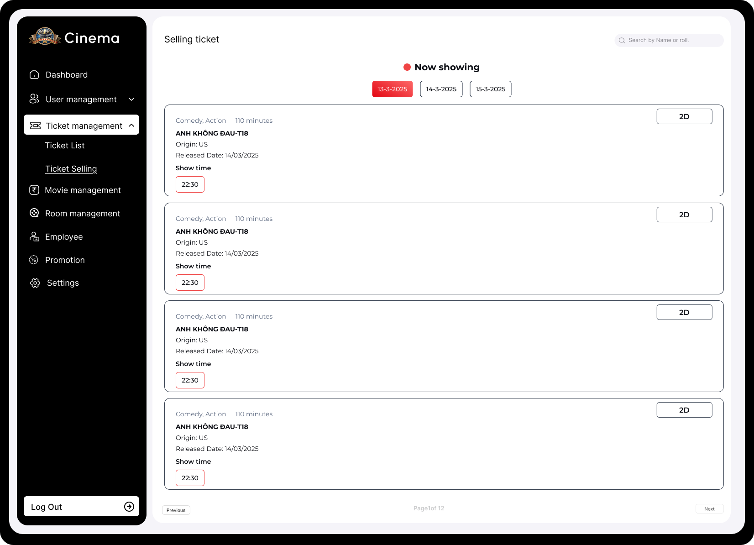

|  |  |  |  |  |
| --- | --- | --- | --- | --- |
| **Screen** | Booking ticket – Select movie and showtime | | | |
| **Description** | Display current movies and showtime | | | |
| **Screen**  **Access** | The user accesses Booking ticket | | | |
| **Screen Content** | | | | |
| **Item** | **Type** | **Data** | **Description** | |
| Date | Combobox | N/A |  | |
| Showtime | Button | N/A |  | |
| Movie name | Label | N/A |  | |
| Time | Link | N/A |  | |
| **Screen Action** | | | | |
| **Action name** | **Description** | | **Success** | **Failure** |
| View showtime | Display list of show dates for the user to select | | Display showtime list of current movies | If no showtime has been found, display message: “No  showtime” |
| Showtime | Display showtime of each movie | | Send information of movies and showtimes, display the Select seat  screen |  |

#### Ticket selling management – Selecting seat

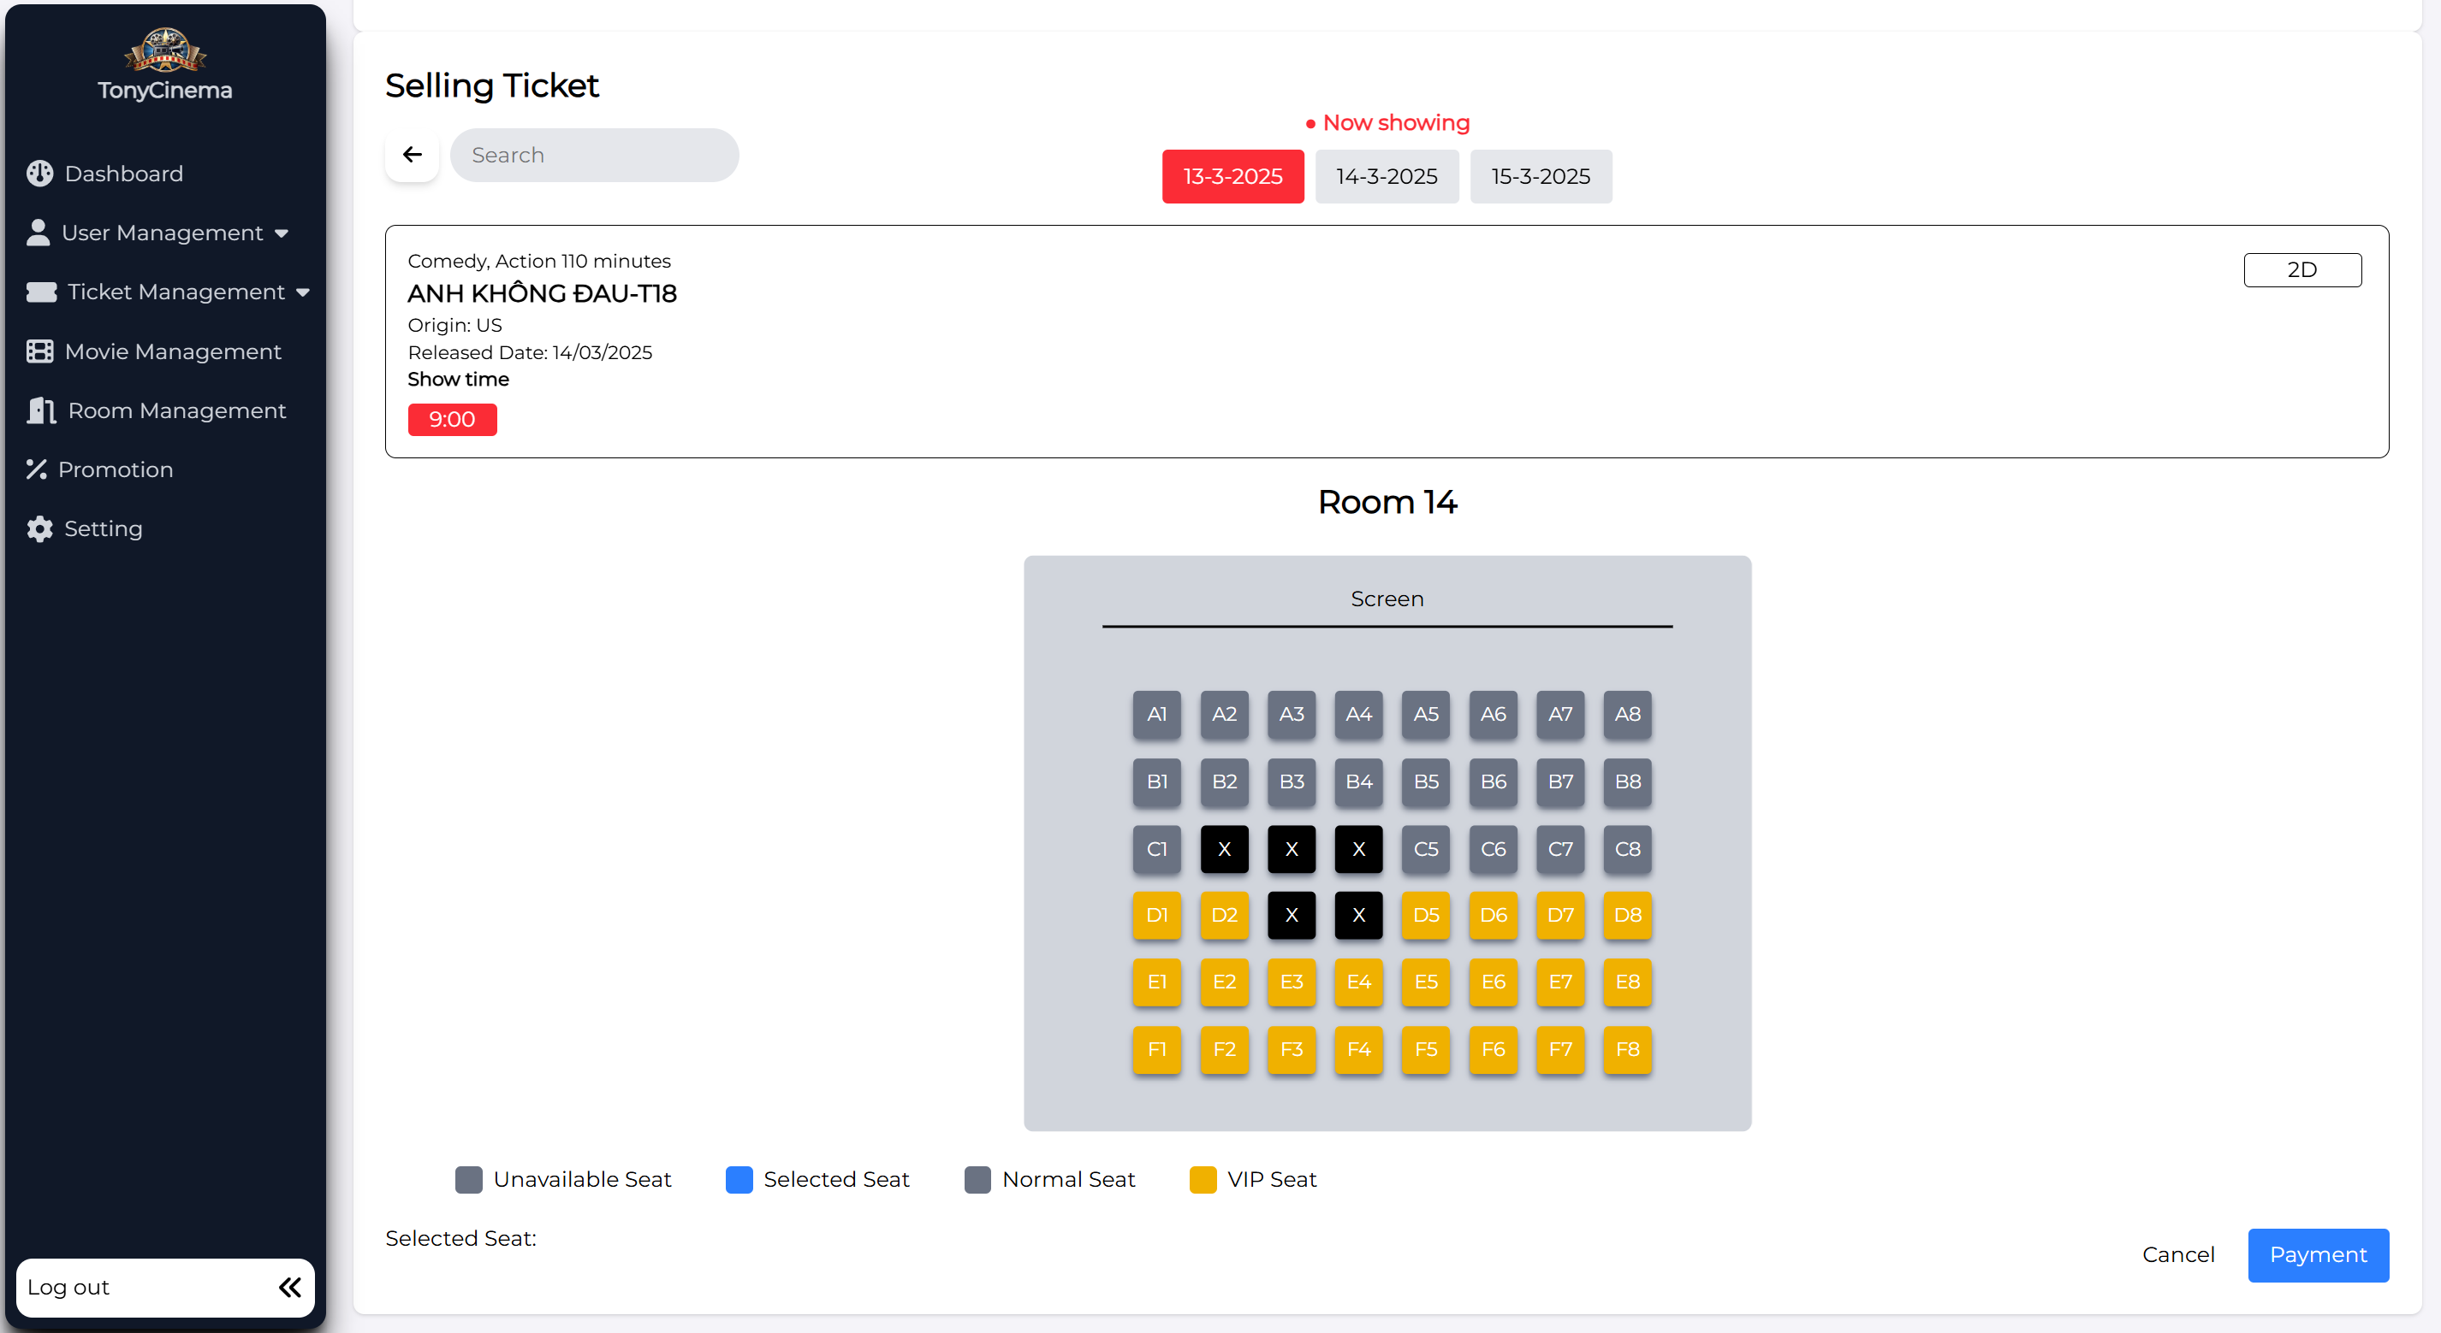

|  |  |  |  |  |
| --- | --- | --- | --- | --- |
| **Screen** | Booking ticket – Select seat | | | |
| **Description** | Display seat map of the movie and selected showtime | | | |
| **Screen**  **Access** | The user accesses after selecting movie and showtime | | | |
| **Screen Content** | | | | |
| **Item** | **Type** | **Data** | **Description** | |
| Select seat  quanity | Combobox | N/A | Display list of seat quantity for the  user to select | |
| Seat | CheckBox | N/A | Display seat map for the user to select | |
| Continue | Button | N/A | Send information of selecting seat and  display ticket booking information | |
| **Screen Action** | | | | |
| **Action name** | **Description** | | **Success** | **Failure** |

|  |  |  |  |
| --- | --- | --- | --- |
| Select seat  quantity | Display list of seat quantity that  customer needs (0, 1, 2, …8) | Display list of seat  quantity |  |
| Select seat | Display seat map, the employee chooses seat according to selected seat quantity at Combobox of Select seat quantity. | When selecting the seat number as the same as selected seat quantity in combobox of Select seat quantity | If selected seat number is less than the seat quantity at the combobox, display the message "Please selecte x seat more"  - If selected seat number is more than the seat quantity at the combo, display the message "Please select only x  seat" |
| Continue | Send ticket booking request, send seat  selection information and display booking information screen | Display Confirm  booking ticket screen |  |

#### Ticket selling management – Confirm ticket

|  |  |  |  |
| --- | --- | --- | --- |
| **Screen** | Ticket selling management – Confirm ticket | | |
| **Description** | Display all ticket selling information | | |
| **Screen**  **Access** | The user accesses after selecting seat | | |
| **Screen Content** | | | |
| **Item** | **Type** | **Data** | **Description** |
| Movie name | Label | N/A |  |
| Screen | Label | N/A |  |
| Date | Label | N/A |  |
| Time | Label | N/A |  |
| Seat | Label | N/A |  |
| Price | Label | N/A |  |
| Total | Label | N/A |  |
| Member | Textbox | N/A |  |
| Check | Button | N/A |  |
| Member ID | Label | N/A |  |

|  |  |  |  |  |
| --- | --- | --- | --- | --- |
| Identity card | Label | N/A |  | |
| Full name | Label |  |  | |
| Member  score | Label | N/A |  | |
| Convert to  ticket | Radio | N/A |  | |
| Phone  number | Label | N/A |  | |
| Confirm  booking ticket | Button | N/A |  | |
| **Screen Action** | | | | |
| **Action name** | **Description** | | **Success** | **Failure** |
| Confirm booking ticket | Select Confirm booking ticket to send all ticket booking information | | Send information of ticket selling, display screen of ticket booking information | If the member converts score into ticket, while score is not enough to convert, display message: “Member score is not enough to convert into  ticket” |
| Check member | Input member ID or identity card number to get information of member | | Display information of member | Display the message: “No member has  found!” |
| Convert to ticket | Select number of tickets that the member wants to conver into | | When number of converted tickets matches with enough member  score |  |

#### Ticket selling management – Ticket information

|  |  |  |  |
| --- | --- | --- | --- |
| **Screen** | Ticket selling management – Ticket information | | |
| **Description** | Display all ticket information | | |
| **Screen**  **Access** | The user accesses after selecting seat | | |
| **Screen Content** | | | |
| **Item** | **Type** | **Data** | **Description** |
| Movie name | Label | N/A |  |
| Ticket  booking ID | Label | N/A |  |
| Screen | Label | N/A |  |
| Date | Label | N/A |  |
| Time | Label | N/A |  |
| Seat | Label | N/A |  |
| Price | Label | N/A |  |
| Convert to  ticket | Label | N/A |  |

|  |  |  |  |  |
| --- | --- | --- | --- | --- |
| Score for ticket  converting | Label | N/A |  | |
| Total | Label | N/A |  | |
| Member ID | Label | N/A |  | |
| Email | Label | N/A |  | |
| Identity card | Label | N/A |  | |
| Phone  number | Label | N/A |  | |
| **Screen Action** | | | | |
| **Action name** | **Description** | | **Success** | **Failure** |

### Ticket booking management

|  |  |
| --- | --- |
| Use Case  Name | Ticket booking management |
| Use Case ID |  |
| High Level  Requirement Ref |  |
| Actor | Admin/Manager/Employee |
| Description | Allows the users to manage ticket booking of members |
| Trigger | NA |
| Pre-condition | The user must log in the system |
| Post-  processing |  |

#### Ticket booking management – Search



|  |  |
| --- | --- |
| **Screen** | Ticket booking management - Search |
| **Description** | Display current movies and showtime |
| **Screen**  **Access** | The user accesses Ticket booking management |

|  |  |  |  |  |
| --- | --- | --- | --- | --- |
| **Screen Content** | | | | |
| **Item** | **Type** | **Data** | **Description** | |
| Search | Textbox | N/A | Input the keywords to search including Booking ID, account ID, phone number or identity card number of  booking account | |
| Search | Button | N/A | Select Search button | |
| **Screen Action** | | | | |
| **Action name** | **Description** | | **Success** | **Failure** |
| Search | Click the search button, the booking list will filter the data  Filtering data by keyword entered in the search textbox matches with the booking code, account code, phone number or identity card number of the booking account, then display on the  list | | Display the booking list of the account | Show the message "No booking found!" |

#### Ticket booking management – Booking list

|  |  |
| --- | --- |
| **Screen** | Ticket booking management – Booking list |
| **Description** | Display current movies and showtime |
| **Screen**  **Access** | The user accesses Booking ticket |

|  |  |  |  |  |
| --- | --- | --- | --- | --- |
| **Screen Content** | | | | |
| **Item** | **Type** | **Data** | **Description** | |
| Booking ID | Label | N/A |  | |
| Identity card | Label | N/A |  | |
| Phone  number | Label | N/A |  | |
| Movie | Label | N/A |  | |
| Time | Label | N/A |  | |
| Successful  booking | Button | N/A |  | |
| **Screen Action** | | | | |
| **Action name** | **Description** | | **Success** | **Failure** |
| Confirm booking | Click Confirm booking to view booking information | | Display information of booking detail of  member |  |

#### Ticket booking management – Confirm booking

|  |  |  |  |  |
| --- | --- | --- | --- | --- |
| **Screen** | Booking management – Confirm booking | | | |
| **Description** | Display all booking information | | | |
| **Screen**  **Access** | The user accesses after selecting booking ticket at booking list | | | |
| **Screen Content** | | | | |
| **Item** | **Type** | **Data** | **Description** | |
| Movie name | Label | N/A |  | |
| Booking ID | Label | N/A |  | |
| Screen | Label | N/A |  | |
| Date | Label | N/A |  | |
| Time | Label | N/A |  | |
| Seat | Label | N/A |  | |
| Price | Label | N/A |  | |
| Total | Label | N/A |  | |
| Member ID | Label | N/A |  | |
| Full name | Label | N/A |  | |
| Member  score | Label | N/A |  | |
| Identity card | Label | N/A |  | |
| Convert to  ticket | Radio | N/A |  | |
| Phone  number | Label | N/A |  | |
| Confirm  booking | Button | N/A |  | |
| **Screen Action** | | | | |
| **Action name** | **Description** | | **Success** | **Failure** |
| Member score | Click to convert member score into ticket | | Display screen Information of converting score into ticket | Display message: “Not enough score to convert into  ticket” |
| Confirm booking | Click to send request to confirm converting score into ticket | | Confirm converting into ticket, display ticket booking  management |  |

#### Ticket booking management – Information of converting into ticket

|  |  |  |  |
| --- | --- | --- | --- |
| **Screen** | Booking management – Confirm booking successfully | | |
| **Description** | Display all booking information | | |
| **Screen**  **Access** | The user accesses after selecting Booking ticket at booking list | | |
| **Screen Content** | | | |
| **Item** | **Type** | **Data** | **Description** |
| Movie name | Label | N/A |  |
| Booking ID | Label | N/A |  |
| Screen | Label | N/A |  |
| Date | Label | N/A |  |
| Time | Label | N/A |  |
| Seat | Label | N/A |  |
| Price | Label | N/A |  |
| Convert to  ticket | Label | N/A |  |
| Score for ticket  converting | Label | N/A |  |

|  |  |  |  |  |
| --- | --- | --- | --- | --- |
| Total | Label | N/A |  | |
| Member ID | Label | N/A |  | |
| Full name | Label | N/A |  | |
| Identity card | Label | N/A |  | |
| Phone  number | Label | N/A |  | |
| **Action name** | **Description** | | **Success** | **Failure** |

### User Management

|  |  |
| --- | --- |
| Use Case Name | User management |
| Use Case ID |  |
| High Level Requirement  Ref | Admin/Manager |
| Actor | The function allows to add, edit, delete, change password of employee and view customer list |
| Description | N/A |
| Trigger | Only admin has right to implement functions |
| Pre-condition | Admin must login the system |
| Post-processing |  |

#### Employee management – View employee list

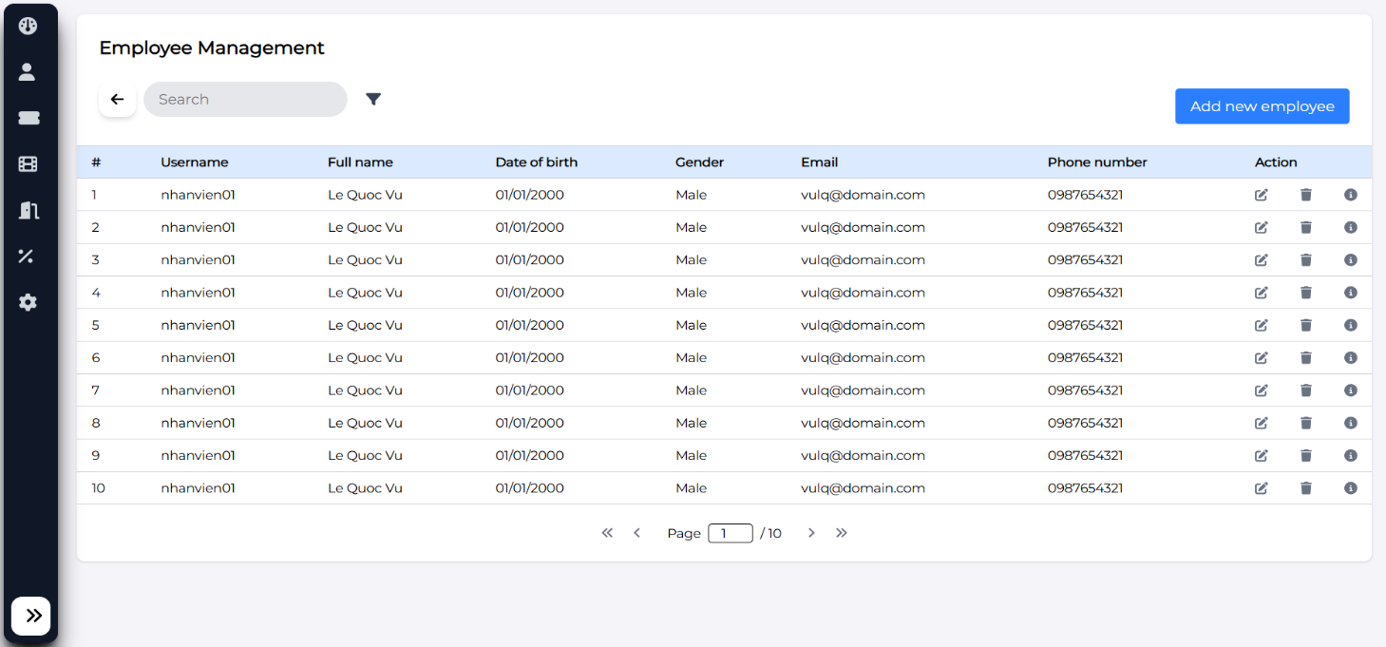

|  |  |  |  |  |
| --- | --- | --- | --- | --- |
| **Screen** | Screen to display employee list | | | |
| **Description** | Function of viewing information of movie theater employee  Allows to search, add, edit, delete employees | | | |
| **Screen**  **Access** |  | | | |
| **Screen Content** | | | | |
| **Item** | **Type** | **Data** | **Description** | |
| **Employee ID** | **Label** |  |  | |
| **Employee**  **name** | **Label** |  |  | |
| **Identity card** | **Label** |  |  | |
| **Email** | **Label** |  |  | |
| **Phone**  **number** | **Label** |  |  | |
| **Address** | **Label** |  |  | |
| **Edit** | **Button** | **N/A** |  | |
| **Delete** | **Button** | **N/A** |  | |
| **Add** | **Button** | **N/A** |  | |
| **Search** | **TextBox - nvarchar**  **(28)** | **N/A** |  | |
| **Search** | **Button** | **N/A** |  | |
| **Screen Action** | | | | |
| **Action name** | **Description** | | **Success** | **Failure** |
| Add | Click Add employee button to add an  employee | | Forward to Add  employee function | N/A |
| Edit | Click Edit employee button to edit  information of an employee | | Forward to Edit  employee function | N/A |
| Delete | Click Delete employee button to delete  information of an employee | | Forward to Delete  employee function | N/A |
| Search | 1. Input keyword into Input_Text Search 2. Click Search button | | List of all related employees that have been derived from the input keyword | N/A |

#### Employee management – Add employee

|  |  |  |  |
| --- | --- | --- | --- |
| **Screen** | Screen to add employee | | |
| **Description** | Function to add employee | | |
| **Screen**  **Access** |  | | |
| **Screen Content** | | | |
| **Item** | **Type** | **Data** | **Description** |
| Image | Button | N/A |  |
| Account | TextBox -  nvarchar (28) | N/A |  |
| Password | TextBox -  nvarchar (28) | N/A |  |
| Confirm  password | TextBox -  nvarchar (28) | N/A |  |
| Date of birth | DataDatetime | N/A |  |
| Sex | checkbox | N/A |  |
| Employee  name | TextBox -  nvarchar (28) | N/A |  |
| Identity card | TextBox -  nvarchar (28) | N/A |  |

|  |  |  |  |  |
| --- | --- | --- | --- | --- |
| Email | TextBox -  nvarchar (28) | N/A |  | |
| Phone  number | TextBox -  nvarchar (28) | N/A |  | |
| Address | TextBox -  nvarchar (28) | N/A |  | |
| Add | Button | N/A |  | |
| Back | Button |  |  | |
| **Screen Action** | | | | |
| **Action name** | **Description** | | **Success** | **Failure** |
| Add | Add employee | | Add inputted employee information into database.  Forward to Employee management screen – View employee  list | Display the message: “The inputted account is already existed, please choose another account name” |
| Back | Back to previous screen | | Back to previous  screen | N/A |

#### Employee management – Edit employee

|  |  |  |  |
| --- | --- | --- | --- |
| **Screen** | Screen to edit employee | | |
| **Description** | Function to edit employee information | | |
| **Screen**  **Access** |  | | |
| **Screen Content** | | | |
| **Item** | **Type** | **Data** | **Description** |
| Image | Button | Display image of  the selected employee to edit |  |
| Account | TextBox - nvarchar (28) | Display account  name of selected employee to edit |  |
| Password | TextBox -  nvarchar (28) | N/A |  |
| Confirm  password | TextBox -  nvarchar (28) | N/A |  |
| Full name | TextBox - nvarchar (28) | Display full name of selected  employee to edit |  |

|  |  |  |  |  |
| --- | --- | --- | --- | --- |
| Date of birth | DataDatetime | Display date of birth of selected  employee to edit |  | |
| Sex | chechbox | Display sex of selected employee  to edit |  | |
| Email | TextBox - nvarchar (28) | Display email of selected employee  to edit |  | |
| Identity card | TextBox - nvarchar (28) | Display identity card number of selected employee  to edit |  | |
| Phone number | TextBox - nvarchar (28) | Display phone number of selected employee  to edit |  | |
| Address | TextBox - nvarchar (28) | Display address of  selected employee to edit. |  | |
| Edit | Button | N/A | Click to edit employee | |
| Back | Button |  | Back to the previous screen | |
| **Screen Action** | | | | |
| **Action name** | **Description** | | **Success** | **Failure** |
| Edit | Edit information of an employee | | Edit successfully information of an employee. Edit information of employee in database. Forward to screen of employee management –  View employee list | N/A |
| Back | Back to the previous screen | | Back to the  previous screen | N/A |

#### Employee management – Delete employee

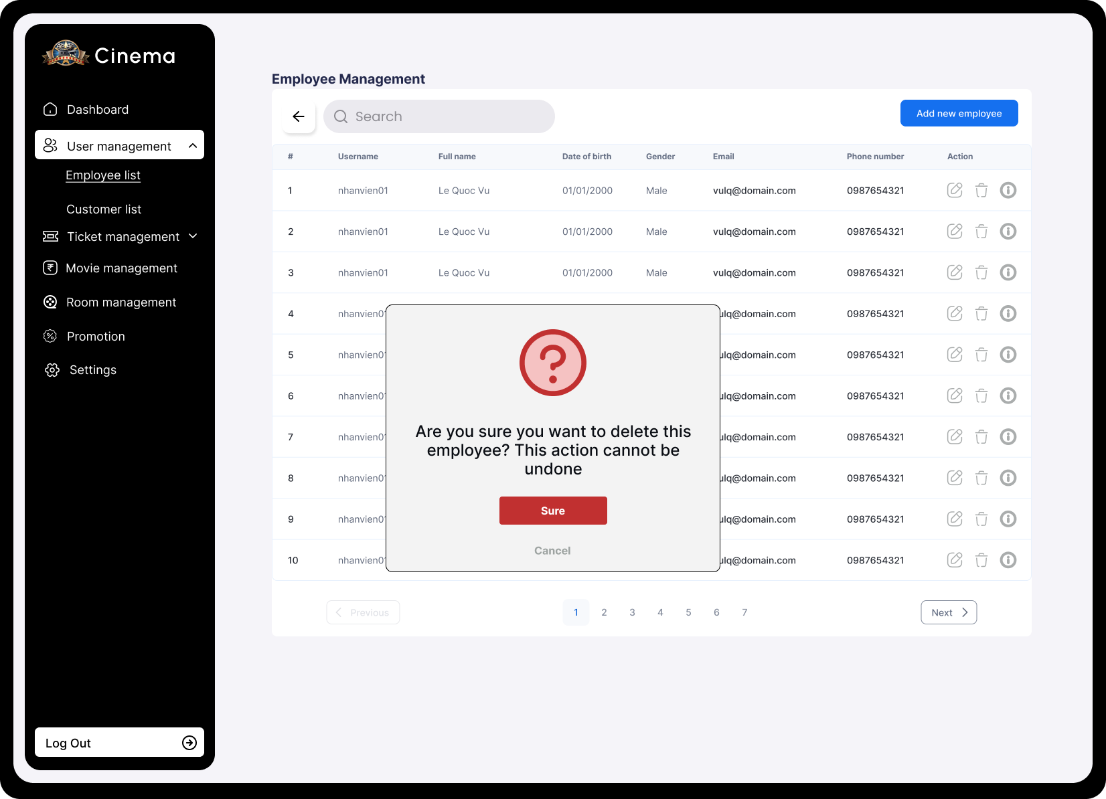

|  |  |  |  |
| --- | --- | --- | --- |
| **Screen** | Employee management – Delete movie | | |
| **Description** | Delete movie information | | |
| **Screen Access** | Admin clicks menu Movie management -> Delete | | |
| **Screen Content** | | | |
| **Item** | **Type** | **Data** | |
| Yes | Button |  | |
| No | Button |  | |
| **Screen Actions** | | | |
| **Action Name** | **Description** | | **Success** |
| Confirm | Agree to delete movie | | Movie is deleted from database and display screen  of movie list |
| No | Close confirm screen | | Display screen of movie list |

|  |  |  |  |
| --- | --- | --- | --- |
| **Screen** | Screen to delete employee | | |
| **Description** | Function to delete employee information | | |
| **Screen**  **Access** |  | | |
| **Screen Content** | | | |
| **Item** | **Type** | **Data** | **Description** |
| Image | FormFile | Display image of  selected employee to edit |  |
| Account | TextBox - nvarchar (28) | Display account of  selected employee to edit |  |
| Password | TextBox -  nvarchar (28) | N/A |  |
| Confirm  password | TextBox -  nvarchar (28) | N/A |  |

|  |  |  |  |  |
| --- | --- | --- | --- | --- |
| Full name | TextBox - nvarchar (28) | Display full name of selected  employee to edit |  | |
| Date of birth | DataDatetime | Display Date of birth of selected  employee to edit |  | |
| Sex | chechbox | Display sex of selected employee  to edit |  | |
| Email | TextBox - nvarchar (28) | Display email of  selected employee to edit. |  | |
| Identity card | TextBox - nvarchar (28) | Display identity card number of selected employee  to edit |  | |
| Phone number | TextBox - nvarchar (28) | Display phone number of selected employee  to edit |  | |
| Address | TextBox - nvarchar (28) | Display address of  selected employee to edit. |  | |
| Delete | Button | N/A | Click to Delete employee | |
| Back | Button |  | Back to the previous screen | |
| **Screen Action** | | | | |
| **Action name** | **Description** | | **Success** | **Failure** |
| Delete | Delete an employee | | Successfully deleting an employee is changing status of the employee into Disable(2) in database. Forward to screen: Employee management –  View employee list. | N/A |

|  |  |  |  |
| --- | --- | --- | --- |
| Back | Back to the previous screen | Back to the  previous screen | N/A |

#### Customer management – View customer list

|  |  |  |  |
| --- | --- | --- | --- |
| **Screen** | Screen to display customer list | | |
| **Description** | Function of viewing information of movie theater customer  Allows to search and delete customers | | |
| **Screen**  **Access** |  | | |
| **Screen Content** | | | |
| **Item** | **Type** | **Data** | **Description** |

|  |  |  |  |  |
| --- | --- | --- | --- | --- |
| User name | Label |  |  | |
| User full name | Label |  |  | |
| Date of Birth | Label |  |  | |
| Gender | Label |  |  | |
| Phone  number | Label |  |  | |
| Email | Label |  |  | |
| Create At | Button | N/A |  | |
| Delete | Button | N/A |  | |
| Search | TextBox - nvarchar  (28) | N/A |  | |
| Search | Button | N/A |  | |
| **Screen Action** | | | | |
| **Action name** | **Description** | | **Success** | **Failure** |
| Delete | Click Delete customer button to delete  information of a customer | | Forward to Delete  customer function | N/A |
| Search | 1. Input keyword into Input_Text Search 2. Click Search button | | List of all related employees that have been derived from the input keyword | N/A |

### Cinema room management

|  |  |
| --- | --- |
| Use Case Name | Cinema room management |
| Use Case ID |  |
| High Level Requirement  Ref | Admin, user |
| Actor | Allows to add cinema room |
| Description | NA |
| Trigger | Only admin has right to implement functions |
| Pre-condition | Admin must login the system |

#### Cinema room management – Display list of cinema rooms

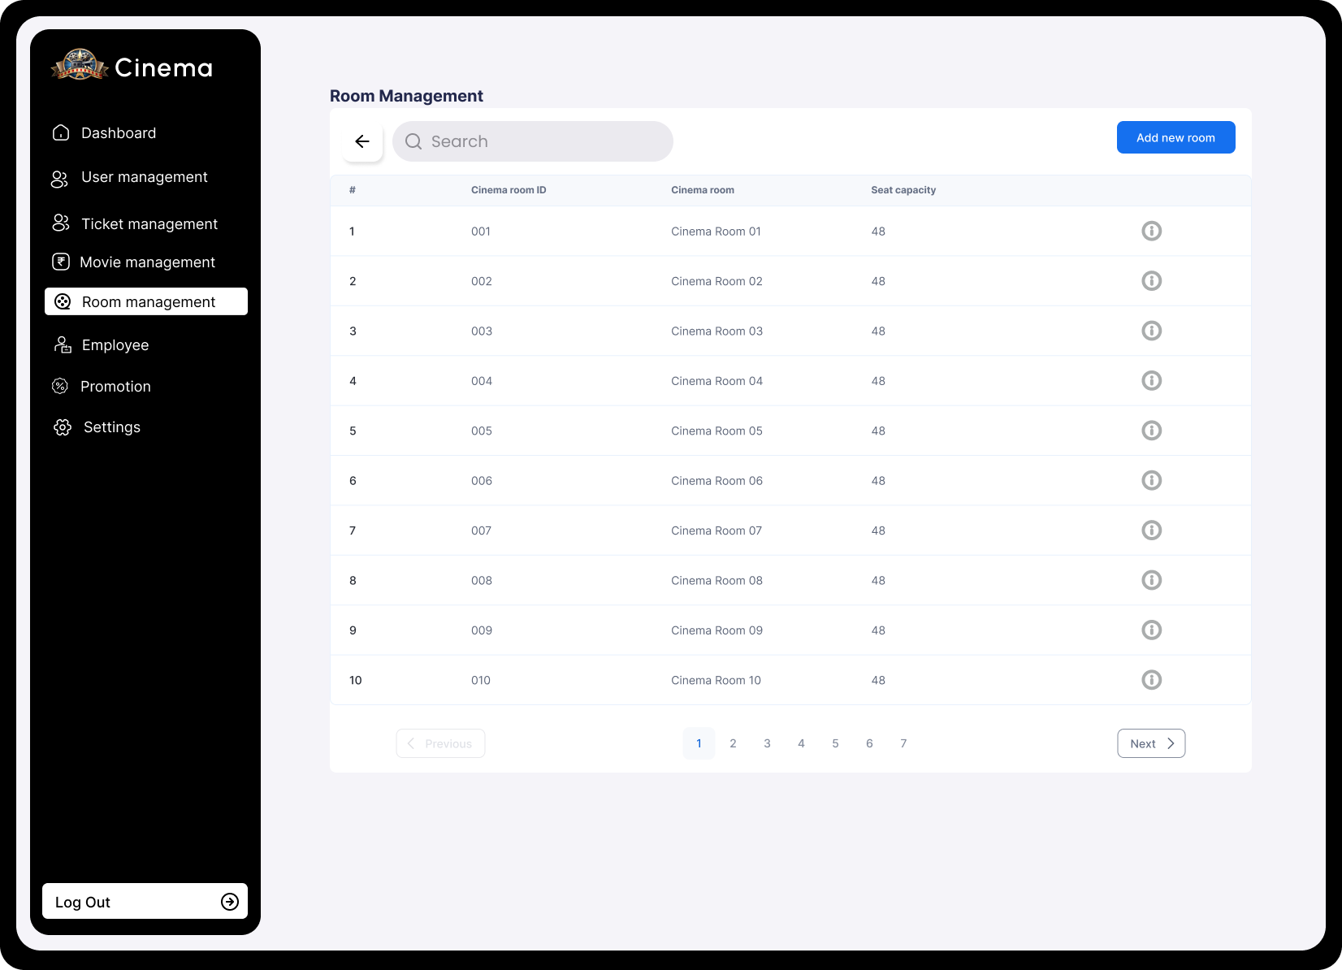

|  |  |  |  |
| --- | --- | --- | --- |
| **Screen** | Screen to display cinema room list | | |
| **Description** | Function to view list of cinema room information and search for keyword  Allows to add, edit cinema room seat types | | |
| **Screen**  **Access** |  | | |
| **Screen Content** | | | |
| **Item** | **Type** | **Data** | **Description** |
| Cinema room  ID | Label |  |  |

|  |  |  |  |  |
| --- | --- | --- | --- | --- |
| Cinema room | Label |  |  | |
| Seat quantity | Label |  |  | |
| Seat detail | Button | N/A |  | |
| Add cinema  room | Button | N/A |  | |
| Search | TextBox - nvarchar  (28) | N/A |  | |
| Search | Button | N/A |  | |
| **Screen Actions** | | | | |
| **Action name** | **Description** | | **Success** | **Failure** |
| Seat detail | Click Seat detail button of each cinema room to view detail, edit seat type in that cinema room. | | Forward to Cinema room detail screen and implement functions of cinema  room details. | N/A |
| Search | 1. Input keyword into Input_Text Search 2. Click Search button | | Updated Cinema room list is list of cinema room according to search  keyword. | N/A |
| Back | Back to previous screen | | Back to previous  screen | N/A |

#### Cinema room management – Cinema room detail

|  |  |  |  |  |
| --- | --- | --- | --- | --- |
| **Screen** | Detail screen of cinema room | | | |
| **Description** | Function to view information and edit seat type in selected cinema room | | | |
| **Screen**  **Access** |  | | | |
| **Screen Content** | | | | |
| **Item** | **Type** | **Data** | **Description** | |
| Cinema room | Label |  |  | |
| Seat | Checkbox |  |  | |
| Save | Button | N/A |  | |
| Back | Button | N/A |  | |
| **Screen Action** | | | | |
| **Action name** | **Description** | | **Success** | **Failure** |
| Select seat | Select seat to change status of the seat from this status into another status  (Normal seat – VIP seat) | | Selected seat color is changed into  green color | N/a |
| Save | Click to save change in database | | Edit successfully in database. Change status of selected  seats. Return screen | .  Re-display the screen of this function. |

|  |  |  |  |
| --- | --- | --- | --- |
|  |  | of cinema room management |  |

### Movie management

|  |  |
| --- | --- |
| Use Case  Name | Movie management |
| Use Case ID |  |
| High Level Requirement  Ref |  |
| Actor | Admin/Manager |
| Description | Allows admin to view, add, edit movie information |
| Trigger | The user must log in the system as admin right |
| Pre-condition |  |

#### Movie management – View movie list

|  |  |  |  |
| --- | --- | --- | --- |
| **Screen** | View movie list | | |
| **Description** | Display movie list | | |
| **Screen Access** | The user clicks **Movie management** | | |
| **Screen Content** | | | |
| **Item** | **Type** | **Data** | **Description** |
| Movie | Lable –  String | N/A |  |
| Release date | Lable –  String | N/A |  |

|  |  |  |  |  |  |  |
| --- | --- | --- | --- | --- | --- | --- |
| Movie production  company | | Lable –  String | N/A | |  | |
| Movie running  time | | Lable –  Number | N/A | |  | |
| Version | | Lable –  String | N/A | |  | |
| Edit | | Button | N/A | |  | |
| Add movie | | Button | N/A | |  | |
| **Screen Action** | | | | | | |
| **Action name** | **Description** | | | **Success** | | **Failure** |
| Add movie | Forward to page of adding movie | | | Display page of  adding movie | |  |
| Edit | Forward to page of editing movie | | | Display page of  editing movie | |  |

#### Movie management – Add movie

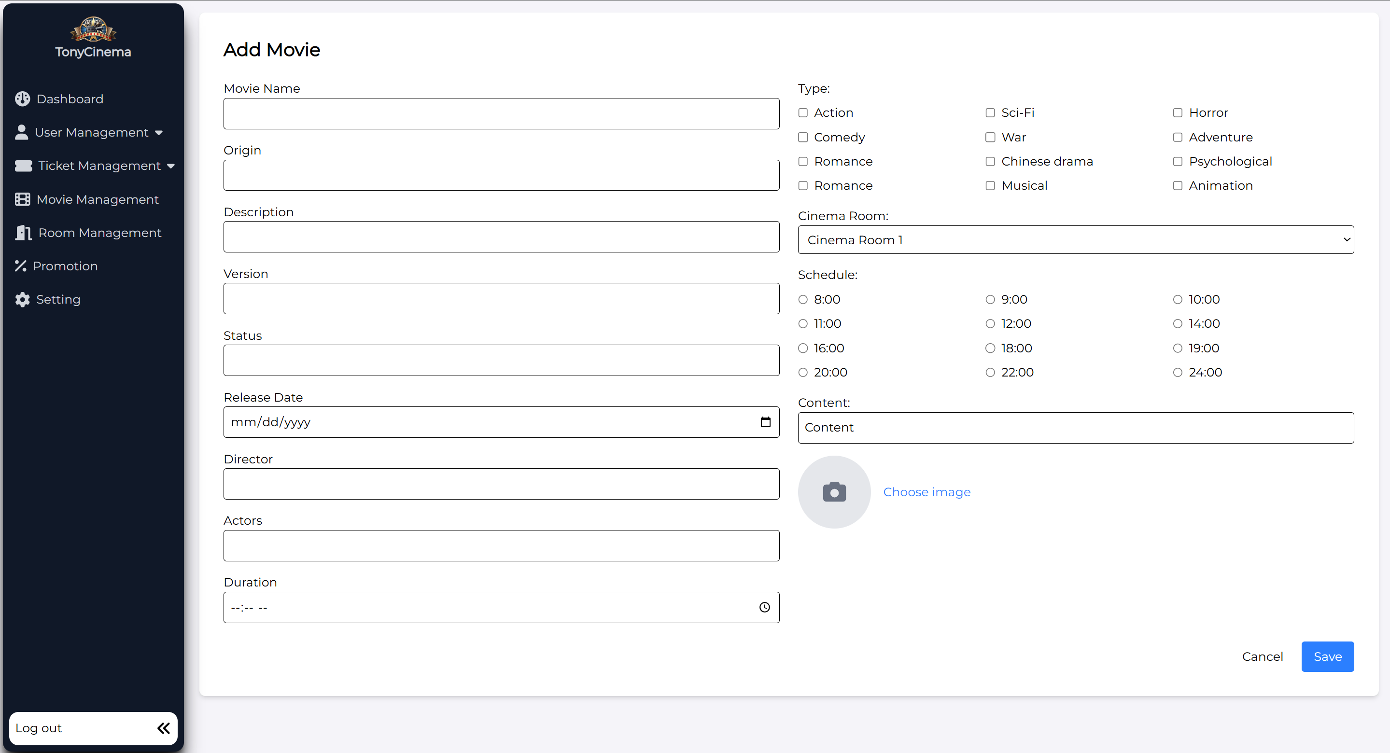

|  |  |  |  |
| --- | --- | --- | --- |
| **Screen** | Add movie | | |
| **Description** | Add 1 movie into database | | |
| **Screen Access** | The user clicks **Movie management -> Add movie** | | |
| **Screen Content** | | | |
| **Item** | **Type** | **Data** | **Description** |
| Movie name | TextBox –  String | N/A |  |
| From date | Date | N/A |  |
| To date | Date | N/A |  |

|  |  |  |  |  |  |  |
| --- | --- | --- | --- | --- | --- | --- |
| Actor | | TextBox –  String | N/A | |  | |
| Movie  production company | | TextBox –  String | N/A | |  | |
| Director | | TextBox –  String | N/A | |  | |
| Running time | | TextBox –  Number | N/A | |  | |
| Version | | RadioBox | N/A | |  | |
| Trailer | | TextBox –  Number | N/A | |  | |
| Type | | CheckBox | N/A | |  | |
| Cinema room | | ComboBox | N/A | |  | |
| Showtime | | TextBox –  String | N/A | |  | |
| Content | | TextBox –  String | N/A | |  | |
| Add cinema  time | | Button | N/A | |  | |
| Choose file | | Button | N/A | |  | |
| Submit | | Button | N/A | |  | |
| **Screen Action** | | | | | | |
| **Action name** | **Description** | | | **Success** | | **Failure** |
| Add movie | Add movie into database, after admin inputs all information, then click Add  movie to add movie. | | | Back to page of Movie management | | Display the error message |

#### Movie management – Edit movie information

|  |  |  |  |
| --- | --- | --- | --- |
| **Screen** | Update movie information | | |
| **Description** | Update information of the movie | | |
| **Screen Access** | The user clicks **Movie management -> Edit** | | |
| **Screen Content** | | | |
| **Item** | **Type** | **Data** | **Description** |

|  |  |  |  |  |  |  |
| --- | --- | --- | --- | --- | --- | --- |
| Movie name | | TextBox –  String | N/A | |  | |
| From date | | Date | N/A | |  | |
| To date | | Date | N/A | |  | |
| Actor | | TextBox –  String | N/A | |  | |
| Movie  production company | | TextBox –  String | N/A | |  | |
| Director | | TextBox –  String | N/A | |  | |
| Running time | | TextBox –  Number | N/A | |  | |
| Version | | RadioBox | N/A | |  | |
| Trailer | | TextBox -  String | N/A | |  | |
| Type | | CheckBox | N/A | |  | |
| Ciname room | | ComboBox | N/A | |  | |
| Showtime | | TextBox –  String | N/A | |  | |
| Content | | TextBox –  String | N/A | |  | |
| Add movie time | | Button | N/A | |  | |
| Choose file | | Button | N/A | |  | |
| Submit | | Button | N/A | |  | |
| Back | | Button | N/A | |  | |
| **Screen Action** | | | | | | |
| **Action name** | **Description** | | | **Success** | | **Failure** |
| Edit | Edit information of movie. After admin edits information, then click Submit to update all information of the  movie. | | | Back to movie management | | Display error messages |

#### Movie management – Delete movie

|  |  |  |  |
| --- | --- | --- | --- |
| **Screen** | Movie management – Delete movie | | |
| **Description** | Delete information of the movie | | |
| **Screen Access** | Admin clicks menu **Movie management -> Delete** | | |
| **Screen Content** | | | |
| **Item** | **Type** | **Data** | |
| Yes | Button |  | |
| No | Button |  | |
| **Screen Actions** | | | |
| **Action Name** | **Description** | | **Success** |
| Confirm | Agree to delete  movies | | The movie is deleted from database and display  Movie list screen |
| No | Close confirm screen | | Display Movie list screen |

### Promotion management

|  |  |
| --- | --- |
| Use Case  Name | Promotion management |
| Use Case ID |  |
| High Level Requirement  Ref |  |
| Actor | Admin |
| Description | Allows users to manage promotion programs of the movie theater |
| Trigger |  |
| Pre-condition | The user must log in the system |
| Post-  processing |  |

#### Promotion management – View promotion list

|  |  |  |  |  |
| --- | --- | --- | --- | --- |
| **Screen** | View promotion list of system | | | |
| **Description** | Allows to search, add, edit, delete promotions | | | |
| **Screen**  **Access** | Admin clicks menu **Promotion management** | | | |
| **Screen Content** | | | | |
| **Item** | **Type** | **Data** | **Description** | |
| Title | Lable –  String | N/A |  | |
| Start time | Lable –  String | N/A |  | |
| End time | Lable –  String | N/A |  | |
| Promotion | Lable –  String | N/A |  | |
| Detail | Lable –  String | N/A |  | |
| Edit | Button | N/A |  | |
| Add | Button | N/A |  | |
| Delete | Button | N/A |  | |
| Search | TextBox -  nvarchar (28) | N/A |  | |
| Search | Button | N/A |  | |
| **Screen Action** | | | | |
| **Action name** | **Description** | | **Success** | **Failure** |

|  |  |  |  |
| --- | --- | --- | --- |
| Add | Click Add promotion button to add a  promotion | Forward to Add  promotion function | N/A |
| Edit | Click Edit promotion button to edit  information of a promotion | Forward to Edit  promotion function | N/A |
| Delete | Click Delete promotion button to  delete information of a promotion | Forward to Delete  promotion function | N/A |
| Search | 1. Input keyword into Input_Text Search 2. Click Search button | Updated promotion list is list of promotion according to search  keyword. | N/A |

#### Promotion management – Add promotion

|  |  |  |  |
| --- | --- | --- | --- |
| **Screen** | Add promotion | | |
| **Description** | Add promotion | | |
| **Screen Access** | Admin clicks menu **Promotion management -> Add promotion** | | |
| **Screen Content** | | | |
| **Item** | **Type** | **Data** | **Description** |
| Image | Button | N/A |  |
| Title | TextBox –  String | N/A |  |
| Start time | ComboBox | N/A |  |
| End time | ComboBox | N/A |  |

|  |  |  |  |  |  |  |
| --- | --- | --- | --- | --- | --- | --- |
| Promotion | | TextBox –  Number | N/A | |  | |
| Detail | | TextBox –  String | N/A | |  | |
| Add | | Button | N/A | |  | |
| Back | | Button |  | |  | |
| **Screen action** | | | | | | |
| **Action name** | **Description** | | | **Success** | | **Failure** |
| Add | After admin inputs and selects all information, then click Add, the system will add a promotion into database | | | Add inputted promotion information into database.  Back to Promotion management screen – View promotion  list | | Display the message: “Unsuccessfully add”. Display Add promotion screen. |
| Back | Back to previous screen | | | Back to previous  screen | | N/A |

#### Promotion management – Edit promotion

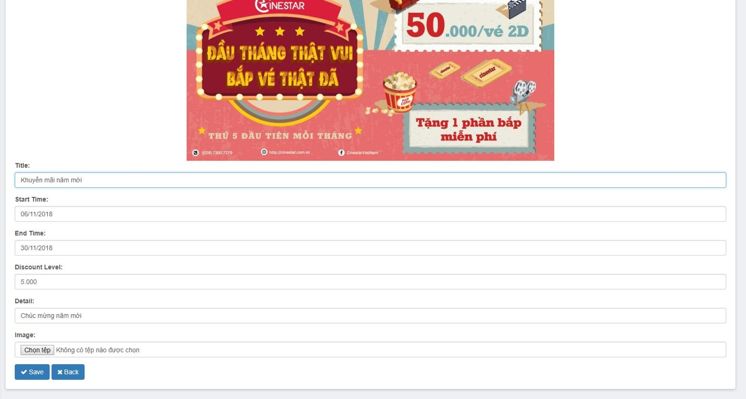

|  |  |  |  |
| --- | --- | --- | --- |
| **Screen** | Edit promotion | | |
| **Description** | Edit information of promotion | | |
| **Screen Access** | Admin clicks menu **Promotion management -> Edit** | | |
| **Screen Content** | | | |
| **Item** | **Type** | **Data** | **Description** |
| Image | Button | Display image of the selected promotion to  edit |  |
| Title | TextBox –  String | Display title of the  selected promotion to edit |  |
| Start time | ComboBox | Display start time of the selected  promotion to edit |  |
| End time | ComboBox | Display end time of the selected  promotion to edit |  |
| Promotion | TextBox –  Number | Display sales off detail of the selected  promotion to edit |  |

|  |  |  |  |  |  |  |
| --- | --- | --- | --- | --- | --- | --- |
| Detail | | TextBox –  String | Display detail of the selected promotion to  edit | |  | |
| Edit | | Button | N/A | |  | |
| **Screen Action** | | | | | | |
| **Action name** | **Description** | | | **Success** | | **Failure** |
| Edit | Edit the information that needs updating of the promotion | | | Display the message “Successfully add”. Edit information of promotion in database. Forward to screen of Promotion management – View promotion  list | | Display the message: “Unsuccessfully add”. Display Edit promotion screen. |
| Back | Back to previous screen | | | Back to previous  screen | | N/A |

#### Promotion management – Delete promotion

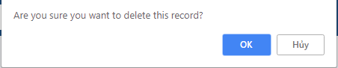

|  |  |  |  |
| --- | --- | --- | --- |
| **Screen** | Delete promotion | | |
| **Description** | Delete information of the promotion | | |
| **Screen Access** | Admin clicks menu **Promotion management -> Delete** | | |
| **Screen Content** | | | |
| **Item** | **Type** | **Data** | |
| Yes | Button |  | |
| No | Button |  | |
| **Screen Actions** | | | |
| **Action Name** | **Description** | | **Success** |

|  |  |  |
| --- | --- | --- |
| Confirm | Agree to delete  promotion | Promotion is deleted from database and display  screen of promotion list |
| No | Close confirm screen | Display screen promotion list |

## Detailed Non-Functional Requirements

### Logical Structure of the Data

The logical structure of the data to be stored on the system is given below

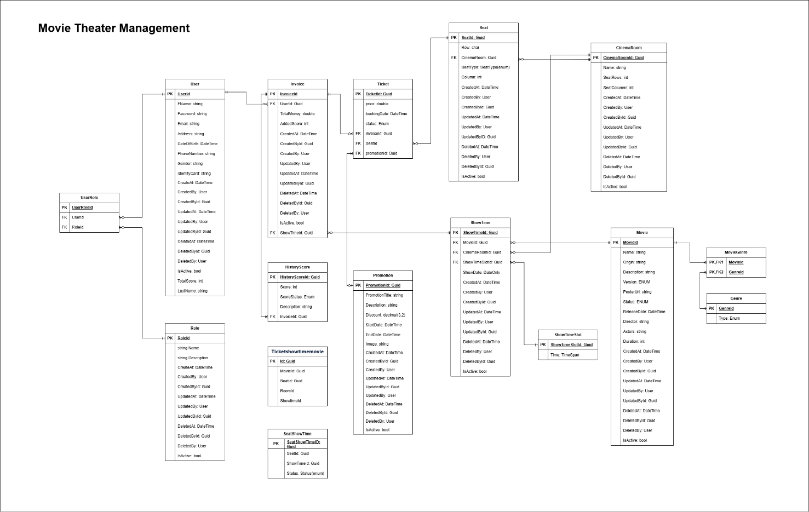

### Security

TBD

### Performance

TBD